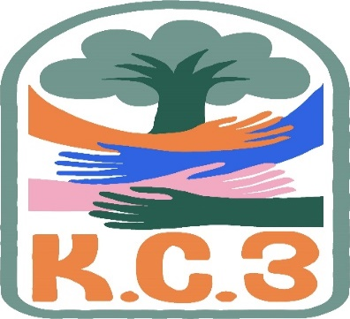
King County Community Collaborative- KC3
Voices of Change and Empowerment
August 22nd, 2023
Virtual meeting
VISION
Together families, youth, communities, and systems will support opportunities to improve the resilience and recovery for all individuals who experience behavioral health challenges. Using an equity lens, we strive to acknowledge and address the disparities within all marginalized communities.

MISSION
Our mission is to create an inclusive space for our community to be heard. In sharing stories of lived experiences, we bring forward the needs, strengths, and opportunities of the current behavioral health system. By taking the challenges and addressing them collectively, we create system change and resolution.

Agenda
Welcome & Introductions: Melody
Invite you to share your name and your role in the chat
If this is your first time and would like to share who you are please feel free too.
Community Input and Concerns:
(Reviewed the comfort agreement as a group due to many new faces being present)
Presentation: Care & Closure Initiative – Emily & Jawara
Shared the evolution from Zero Youth Detention that led us into the Care & Closure project. It aims to better meet the needs of the young people in our community and deter juvenile detention placement.
Goal to “Identify the community-based alternatives to youth detention that addresses the needs and risks of young people...”
Advisory Committee made up of impacted community members with lived experience to guide the process.
Additional subcommittees were created to develop recommendations and report on progress to the Advisory Committee, aiming to identify alternatives to secure youth detention, strengthening community infrastructure, and engaging impacted communities.
Jawara and Emily meeting weekly with youth in detention to assure the voice and perspectives of those most impacted are involved in the process for the Care & Closure project.
Findings from impacted communities include resources focused on supporting youth healing, accountability, and community safety. Feelings that youth detention is not an effective solution.
In the process of developing the recommendations discussed, slides from the presentation shared with KC3.
The primary focus is on care first! Space for comments and questions followed the presentation.
Discussed ways to address the gaps that those in the KC3 community have noticed.
Connect with Jawara and Emily to learn more:
Jawara: jmcduffie@kingcounty.gov
Emily: emijohnson@kingcounty.gov
Sharing Announcements, Updates: All are welcome to share
Moving KC3 Hybrid? – Community Discussion and Survey results
Reviewed the summarized results from the responses submitted. Survey responses showed a preference for continuing KC3 meetings virtually or moving towards a hybrid model. Ideas shared in the meeting are to potentially have one hybrid meeting a quarter, rotating locations to enhance equitable access. The KC3 community will continue to explore this option. Moving meetings to in-person only showed low comfortability from the community as we explored the pros and cons to different meeting models (in-person, virtual, hybrid). The community is encouraged to reach out to the KC3 Tri-Leads with their thoughts or to fill out the following survey to share their thoughts on KC3 meeting model: https://forms.office.com/Pages/ResponsePage.aspx?id=YbBNG8zAfEu5cDffJSn41h1CSkcPf71El_MovLOwOYJUQlUzWVhHQUhPTVhSWVA4OTE0NU5KV09ZWi4u
Community BBQ & Potluck – Planning for next year!
Chuck E. Cheese fundraisers
Update:
GPS – MVP, VIP, and KC3 Incentives (shared ways we hope to compensate volunteers and our community for their input on data collection surveys)
WSCC – STATEWIDE FAMILY NETWORK PARENT/CAREGIVER WEEKEND TRAINING 2023
Workgroups:
Needs Assessment / Workplan
Youth Engagement
KC3 engagement Activity Time – The Price is Right (Half of the game was played after presentation and the other half will be played next month)
Thank you for attending. Be safe, stay well. Next meeting September 26th, 2023

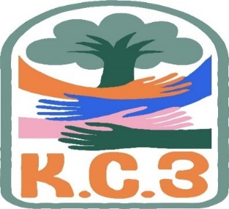

King County Community Collaborative- KC3
Voices of Change and Empowerment
Comfort Agreement

Stay on task
No side conversations
Cell phones on silent
Safe learning environment
Be willing to give and receive feedback
Leave your agency hat at the door. Bring your experience expertise and commitment.
Remember we all bring the best intentions to our work
Value everyone’s opinion
Ask questions and check out your assumptions and thinking
Listen carefully
Let your voice be heard
Provide space to hear about immediate concerns
Seek common ground and action
Identify areas of continued debate and defer to another day
If dissenting, offer an alternative
Be clear about discussion versus decision-making
Start meetings on time
Observe time frames

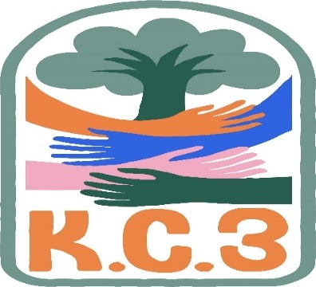

King County Community Collaborative KC3
Voices of Change and Empowerment
Regional FYSPRT
Safety Plan

If anyone during the meeting begins to feel uneasy or frustrated:
- First take a break, Leave the room if needed, and use the coping skills that are familiar to you
- Second reach out to support people in the room
- Third, Tri-leads will offer support to anyone who signals distress-emotionally or otherwise.
- Lastly, reach out to those in the room who have background n de-escalation (all Tri-leads, Convener, Mental Health Provider
KC3 Tri-leads will identify exits for members and attends will know how to safely exit the room if needed
KC3 members and attendees agree to be present, aware and know who in the room (i.e. Tri-leads, Metal Health Providers individuals trained in de-escalation).
KC3 Tri-leads and welcome committee will offer breaks to the group and individuals if conversations get heated or someone is signaling discomfort or distressed,
If Aggressive behavior is present and you have no experience with de-escalation techniques, please find an exit and leave the room.
- IF you do have de-escalation experience you may provide support if you feel comfortable with this. If you feel unsafe or prefer to not engage with an aggressive individual, please find safe space and/or exit the room.

Sharing Resources and information for Families

https://publicinput.com/careandclosure
(More info on the Care & Closure Project)

https://forms.gle/FRdVERZEpU2mYtLFA
(Care & Closure Subcommittee Interest Form)

