King County Community Collaborative- KC3
Voices of Change and Empowerment
July 25th, 2023
Virtual meeting
VISION
Together families, youth, communities, and systems will support opportunities to improve the resilience and recovery for all individuals who experience behavioral health challenges. Using an equity lens, we strive to acknowledge and address the disparities within all marginalized communities.

MISSION
Our mission is to create an inclusive space for our community to be heard. In sharing stories of lived experiences, we bring forward the needs, strengths, and opportunities of the current behavioral health system. By taking the challenges and addressing them collectively, we create system change and resolution.

Agenda
Welcome & Introductions: Cole
Invite you to share your name and your role in the chat
If this is your first time and would like to share who you are please feel free too.
- Icebreaker - if you were an ice cream flavor, what would you be and why?
- Explaining WISe & Wraparound explanation

Community Input and Concerns:
Presentation: Scott Swann - KC WISe referrals from CLIP discharges
- Data Overview
- Strategies
  - collaborate with CLIP facilities
- WISe Manual - ambiguity space explained about priorities, and the hardships of CLIP discharges
- Reason for the talk - people aren’t able to access WISe when they need to, so should we use MCOs?
- Asking Questions to Scott - Demonstration program for community services, to get more members into WISe
- Scott’s email address (Scott.Swan@molinahealthcare.com) for people to reach for questions
- Discussion amongst attendees about problems with the getting involved youth/families

Sharing Announcements, Updates: All are welcome to share
Manual/Expectations for the Roles and Comfort Agreement
- Carving in-time for the next meetings on-word
- Change the game to the beginning or half it, or throughout giving away prizes through quizzes to keep families engaged (gift cards starting next month)
- Encompass meeting goals in a way that is relevant to all
- Possible incentive to showing up to the meetings - zoom registration can help override the spam/bots (still okay if they show up just for the gift card)
Moving KC3 Hybrid? – Community Discussion and Survey
- Posted the form in the chat - https://forms.office.com/Pages/ResponsePage.aspx?id=YbBNG8zAfEu5cDffJSn41h1CSkcPf71El_MovLOwOYJUQlUzWVhHQUhPTVhSWVA4OTE0NU5KV09ZWi4u
- Location: Guided Pathways Center in Kent, WA
- Hybrid - projector with members online actively engaged, or in-person with people staying there and possibly potlucks but still in the ideas of what’s comfortable for people. One voice for all in the room in-person, not much technical difficulties. A bit more than 12 people in-person and more people online works (more than 12 people will be needing a bigger room).
- Incentive/Funding for KC3?
  - Looking into it, and not enough info yet…
- Possible Marketing Plan
  - from retreat, youth move nationals document, having committee for marketing
  - Having Taanvi help lead/kickstart the marketing for youth and starting with elevator pitch, marketing strategies, etc…
  - Social Media Promotion - facebook (Taanvi would like to help with that as well)
- Money - incentives and tri-lead budgets
- Information website transferred - https://www.guidedpathways.org/about/volunteer/

Family Youth System Partner Gathering
Update:
GPS – Convening KC3 & Tri-Lead Retreat Outcomes / GPS Events
- Overview of Attendees - new and old
- Talked over the manual with the objective of going over roles and expectations
- Meeting Requirements - talking about comfort agreement, mission, projects, etc…
- Work Plan and action steps - with a strategic timeline of prioritization used
  - Changed the order of the priorities for the action items
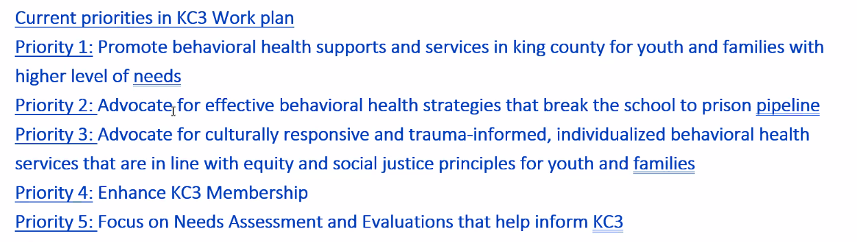
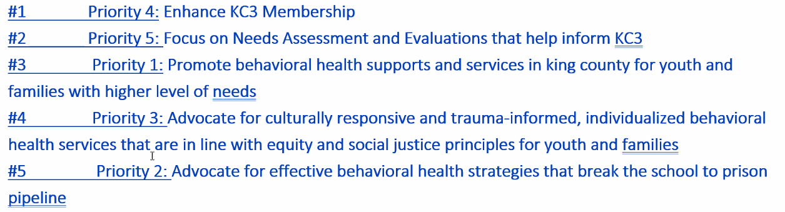
- Talked through the reasons for changing the priorities.
- Will definitely look back on the retreat outcomes.

- Youth Interest in Co-Youth Tri-Lead Role
  - Ishitha Arekapudi - interested in advocating for mental health because of her journey and breaking the stigma, and being engaged in multiple organizations (aviation, library, school, etc…), she can recruit youth and break the stigma so they can get the help they need.
- Discussion about the process to get on the agenda and the chain of command to get the information to action, the systematic approach.
  - Reach out to the Tri-Lead to put it on agenda or during the community input time, share your ideas and information, and then can have the conversation.
  - Formal process for families as well.
- Report to the State/Non-Emergency Medical Transportation
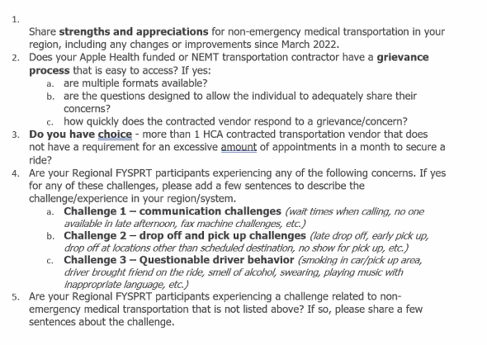

- Having trained uber drivers, people feel safe when having challenges, and to shorten wait times preventing missing appointments.
WSCC
Workgroups:
Needs Assessment / Work Plan
Youth Engagement
KC3 engagement Activity Time
Thank you for attending. Be safe, stay well. Next meeting August 22nd, 2023

King County Community Collaborative- KC3
Voices of Change and Empowerment
Comfort Agreement

Stay on task
No side conversations
Cell phones on silent
Safe learning environment
Be willing to give and receive feedback
Leave your agency hat at the door. Bring your experience, expertise and commitment.
Remember we all bring the best intentions to our work
Value everyone’s opinion
Ask questions and check out your assumptions and thinking

Listen carefully
Let your voice be heard
Provide space to hear about immediate concerns
Seek common ground and action
Identify areas of continued debate and defer to another day
If dissenting, offer an alternative
Be clear about discussion versus decision-making
Start meetings on time
Observe time frames

King County Community Collaborative KC3
Voices of Change and Empowerment
Regional FYSPRT

Safety Plan

If anyone during the meeting begins to feel uneasy or frustrated:
- First take a break, Leave the room if needed, and use the coping skills that are familiar to you
- Second reach out to support people in the room
- Third, Tri-leads will offer support to anyone who signals distress-emotionally or otherwise.
- Lastly, reach out to those in the room who have background n de-escalation (all Tri-leads, Convener, Mental Health Provider
KC3 Tri-leads will identify exits for members and attends will know how to safely exit the room if needed
KC3 members and attendees agree to be present, aware and know who in the room (i.e. Tri-leads, Mental Health Providers individuals trained in de-escalation).
KC3 Tri-leads and welcome committee will offer breaks to the group and individuals if conversations get heated or someone is signaling discomfort or distressed,
If Aggressive behavior is present and you have no experience with de-escalation techniques, please find an exit and leave the room.
- IF you do have de-escalation experience you may provide support if you feel comfortable with this. If you feel unsafe or prefer to not engage with an aggressive individual, please find safe space and/or exit the room.

Sharing Resources and information for Families

https://www.allpreventsuicide.org/

