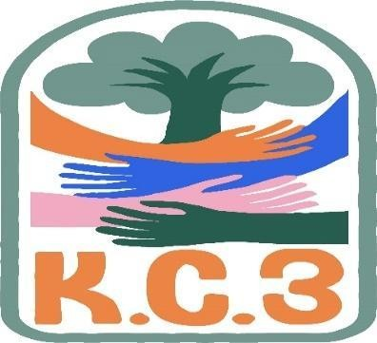
King County Community Collaborative- KC3
Voices of Change and Empowerment
June 27th, 2023
Virtual meeting
VISION

Together families, youth, communities, and systems will support opportunities to improve the resilience and recovery for all individuals who experience behavioral health challenges. Using an equity lens, we strive to acknowledge and address the disparities within all marginalized communities.

MISSION
Our mission is to create an inclusive space for our community to be heard. In sharing stories of lived experiences, we bring forward the needs, strengths, and opportunities of the current behavioral health system. By taking the challenges and addressing them collectively, we create system change and resolution.

Agenda
Welcome & Introductions: Melody
Invite you to share your name and your role in the chat
If this is your first time and would like to share who you are please feel free too.
*Cole introduced Taanvi and everyone voted her in as KC3’s new youth peer. (Cole is stepping down and into system role)

Community Input and Concerns:
Family Youth Professional Partnership Gathering – Event planning
*Melody and Patty brought up the family picnic that will be happening in August 2023.
-Ladies are asking for donations from agencies and volunteers for organization and work to get the picnic planned.

Follow up – KC WISe referrals from CLIP closure
* Everyone spoke about the needs and changes that are happening with CLIP.
-Team spoke about taking the questions talked about to the WISe collaborative.

Presentation: Happy Pride Month! – KC3
Sharing Announcements, Updates: All are welcome to share

GPS
*July 5th 2023 3:30 pm, youth led youth planning event
-Everyone will get a $25 gift card for attending
- free summer dance and drumming events during the summer
*Game night, every other sunday 7/9
*Every thursday evening open house Avreayl
*July 12th 2023 2:30pm, Tukwilla community center Resource fair for providers to help support prenatal care DADS MOVE
*King county dads move support groups twice a month every other thursday
-Participated in Juneteenth
Update:
GPS WSC
*Nobody present
Workgroups:
Needs Assessment / Workplan – Reworking our goals (prioritizing areas of focus)
*Reviewing plan and figuring out the best way to work that out .
-Any specific areas of concern
-how do we obtain more people to join or recruit

Youth Engagement
*spark, youth move, Nami and haley washington all show up Hopefully Taanvi will take it over.
KC3 engagement Activity Time
Thank you for attending. Be safe, stay well. Next meeting July 25th, 2023

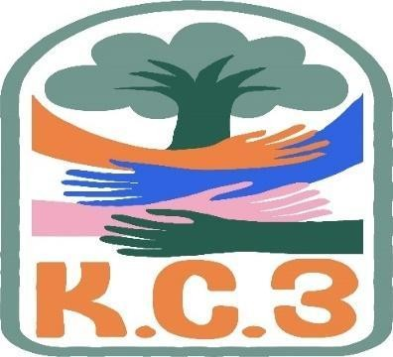

King County Community Collaborative- KC3

Voices of Change and Empowerment
Comfort Agreement
Seek common ground and action

Stay on task
No side conversations Cell phones on silent Safe learning environment
Be willing to give and receive feedback
Leave your agency hat at the door. Bring your experience expertise and commitment.
Remember we all bring the best intentions to our work
Value everyone’s opinion
Ask questions and check out your assumptions and thinking
Listen carefully
Let your voice be heard
Provide space to hear about immediate concerns
Identify areas of continued debate and defer to
another day
If dissenting, offer an alternative
Be clear about discussion versus decision-making
Start meetings on time
Observe time frames

King County Community Collaborative KC3
Voices of Change and Empowerment
Regional FYSPRT
Safety Plan

If anyone during the meeting begins to feel uneasy or frustrated:
  - First take a break, Leave the room if needed, and use the coping skills that are familiar to you
  - Second reach out to support people in the room
  - Third, Tri-leads will offer support to anyone who signals distress-emotionally or otherwise.
  - Lastly, reach out to those in the room who have background n de-escalation (all Tri-leads, Convener, Mental Health Provider
KC3 Tri-leads will identify exits for members and attends will know how to safely exit the room if needed
KC3 members and attendees agree to be present, aware and know who in the room (i.e. Tri-leads, Metal Health Providers individuals trained in de-escalation).
KC3 Tri-leads and welcome committee will offer breaks to the group and individuals if conversations get heated or someone is signaling discomfort or distressed,
If Aggressive behavior is present and you have no experience with de-escalation techniques, please find an exit and leave the room.
  - IF you do have de-escalation experience you may provide support if you feel comfortable with this. If you feel unsafe or prefer to not engage with an aggressive individual, please find safe space and/or exit the room.

Sharing Resources and information for Families

- https://www.lamberthouse.org/
(resources for LGBTQ+ youth and their allies)
- https://www.thetrevorproject.org/
(crisis and suicide prevention for LGBTQ+ youth)
- https://www.pflagseattle.org/
(resources for Parents and Friends of Lesbians and Gays)
- https://ingersollgendercenter.org/
(transgender and gender nonconforming supports)
- https://www.glsen.org/
(supports for LGBTQ+ youth and school inclusion)
- https://www.mccseattle.org/ (LGBTQ+ affirming church)

