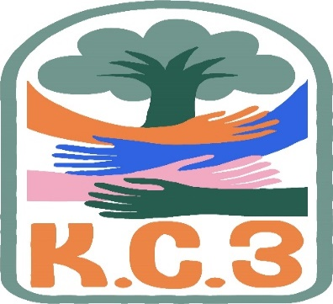
King County Community Collaborative- KC3
Voices of Change and Empowerment
October 24th, 2023
Virtual meeting
VISION
Together families, youth, communities, and systems will support opportunities to improve the resilience and recovery for all individuals who experience behavioral health challenges. Using an equity lens, we strive to acknowledge and address the disparities within all marginalized communities.

MISSION
Our mission is to create an inclusive space for our community to be heard. In sharing stories of lived experiences, we bring forward the needs, strengths, and opportunities of the current behavioral health system. By taking the challenges and addressing them collectively, we create system change and resolution.

Agenda
Welcome & Introductions: LeChez
Invite you to share your name and your role in the chat
If this is your first time and would like to share who you are please feel free too.
Community Input and Concerns:
Input given around not knowing exactly what KC3 is or how to describe what it is to youth and families. One statement made was, “If someone is unsure, we don’t want to just send them there.” Questions arose around where to send people if they have questions about KC3, what this space is about, and why they should be attending. LeChez shared a presentation with the group that highlights those questions asked and can be utilized to share with curious members in the community or other outreach/engagement purposes.
We discussed processes for sharing stories and recommending agenda items, with the plan being that GPS will have a space on their website for community members to ask questions or make suggestions prior to meetings. While it’s okay to bring items with you to meetings for community input and concerns, for some it is more beneficial to have the space carved out ahead of time to promote openness.
Discussions around how people can choose how vulnerable they are in this space. While it is a safe space, it is also a public forum, and confidentiality cannot be promised. Reviewed the comfort agreement as a reminder of ways we can promote safety for those who enter this space. Comfort agreements will be reviewed together more regularly at the beginning of meetings.
KC3 and Land Acknowledgements – Reviewing Duwamish Example
Those in the meeting collectively agreed that the Duwamish Land Acknowledgement will be included in the beginning of our meetings, with the inclusion of space for recognition of other native lands and tribes across King County and space for others to add acknowledgement.
Presentation: Workplan Goal Strategizing (Enhancing KC3 Membership)
KC3 member voiced that they’ve been to various FYSPRTs across the state and notices this topic being a repeated trend. Suggested taking this item to the Statewide FYSPRT for more support, sharing the “state needs to step up” in regard to plans for recruitment for the regional FYSPRTs. Suggested looking into how other states are working on the goal of increasing membership (e.g., PR and investment) and also exploring ways to sustain membership after recruitment. We shared plans for incentives to promote and support youth and family engagement in KC3.
Interest shared in having a future presentation on Occupational Therapy.
Sharing Announcements, Updates: All are welcome to share
Update:
GPS: Ghostly Pathways Haunted House Oct. 27th
WSCC:
Workgroups:
Needs Assessment / Workplan:
Youth Engagement – Taanvi shared about the mental health resource fair she organized for her school to break stigma around mental health and connect students with resources in the community. KC3 and GPS tabled at this event.
KC3 engagement Activity Time – Halloween Emoji Pictionary
Thank you for attending. Be safe, stay well. Next meeting November 28th, 2023

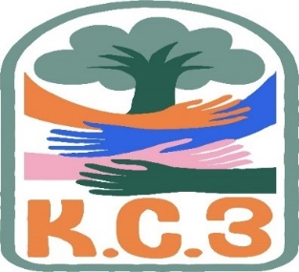

King County Community Collaborative- KC3
Voices of Change and Empowerment
Comfort Agreement

Stay on task
No side conversations
Cell phones on silent
Safe learning environment
Be willing to give and receive feedback
Leave your agency hat at the door. Bring your experience expertise and commitment.
Remember we all bring the best intentions to our work
Value everyone’s opinion
Ask questions and check out your assumptions and thinking

Listen carefully
Let your voice be heard
Provide space to hear about immediate concerns
Seek common ground and action
Identify areas of continued debate and defer to another day
If dissenting, offer an alternative
Be clear about discussion versus decision-making
Start meetings on time
Observe time frames

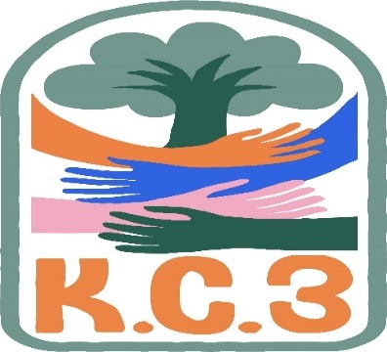

King County Community Collaborative KC3
Voices of Change and Empowerment
Regional FYSPRT
Safety Plan

If anyone during the meeting begins to feel uneasy or frustrated:
- First take a break, Leave the room if needed, and use the coping skills that are familiar to you
- Second reach out to support people in the room
- Third, Tri-leads will offer support to anyone who signals distress-emotionally or otherwise.
- Lastly, reach out to those in the room who have background n de-escalation (all Tri-leads, Convener, Mental Health Provider
KC3 Tri-leads will identify exits for members and attends will know how to safely exit the room if needed
KC3 members and attendees agree to be present, aware and know who in the room (i.e. Tri-leads, Metal Health Providers individuals trained in de-escalation).
KC3 Tri-leads and welcome committee will offer breaks to the group and individuals if conversations get heated or someone is signaling discomfort or distressed,
If Aggressive behavior is present and you have no experience with de-escalation techniques, please find an exit and leave the room.
- IF you do have de-escalation experience you may provide support if you feel comfortable with this. If you feel unsafe or prefer to not engage with an aggressive individual, please find safe space and/or exit the room.

Sharing Resources and information for Families

